Analysis of EEG Signals to Predict Negative Emotions using OpenBCI

Mohammad Asad Shaikh
Department of Information Science and Engineering
K.L.S. Gogte Institute of Technology
Belgaum, India
shaikhasad710@gmail.com
Navaneeth Gowda
Department of Information Science and Engineering
K.L.S. Gogte Institute of Technology
Belgaum, India
navaneethagowda2@gmail.com
Mark Wagh
Department of Information Science and Engineering
K.L.S. Gogte Institute of Technology
Belgaum, India
mark.wagh20@gmail.com
Shrinivas Kulkarni
Department of Information Science and Engineering
K.L.S. Gogte Institute of Technology
Belgaum, India
kulkarnishri3017@gmail.com

Abstract– This paper contains the research-cum-project work carried out by the four of us as a final year engineering project. The purpose of our project is to predict negative emotions such as stress via analysis of EEG signals collected using BCI devices. The pandemic COVID-19 has left behind a huge chaos in the daily lives of people. The post effects of the pandemic are a huge challenge for us to deal. One of the most important issues that the pandemic has left behind is the mental health issue. It is so known that humans have faced huge difficulties and distress that has led to different mental stresses in their daily life due to the pandemic. Considering this we have traced and done a decent research regarding how these mental issues could be sorted. OpenBCI is a Brain Computing Interface (device) that is cost effective, mobile & simple to use, developed by Conor Russomanno & Joel Murphy in 2013 has been a remarkable achievement in the areas of Brain Computing. This paper is based on how we used the OpenBCI in order to detect the negative emotions in humans. These advantages of using the OpenBCI device will help us to easily monitor stress at the comfort of our homes & will help develop cost effective stress monitoring device that could be used by neuro practitioners. The paper encapsulates the challenges that we faced during the initial phase of data collection and analysis; we also present the methods we’ve used for cleaning the raw data obtained. The paper also contains the different applicable types of ML models and provides the results of different ML models that were applied on the datasets.

Introduction
Stress has become an integral part of almost everyone’s life today. People suffer from stress in their daily life. Stress has been defined as “the non-specific response of the body to any demand for change”. It may be physical or emotional response for a particular situation. It affects living beings not only mentally but also physically. Unfortunately, there is no way to avoid stress and we should learn to live with stress. The smart thing that we can do is to monitor stress and analyze the pattern so that we are well trained to manage stress. One of the things we can use to predict stress is to analyze our brain EEG signals. This may not look as an easy option, but technology is evolving and providing us with powerful solutions for every situation. The following Fig 1 below is one such device used to collect the EEG of a human, we generally call these as Brain Computing Interface devices.
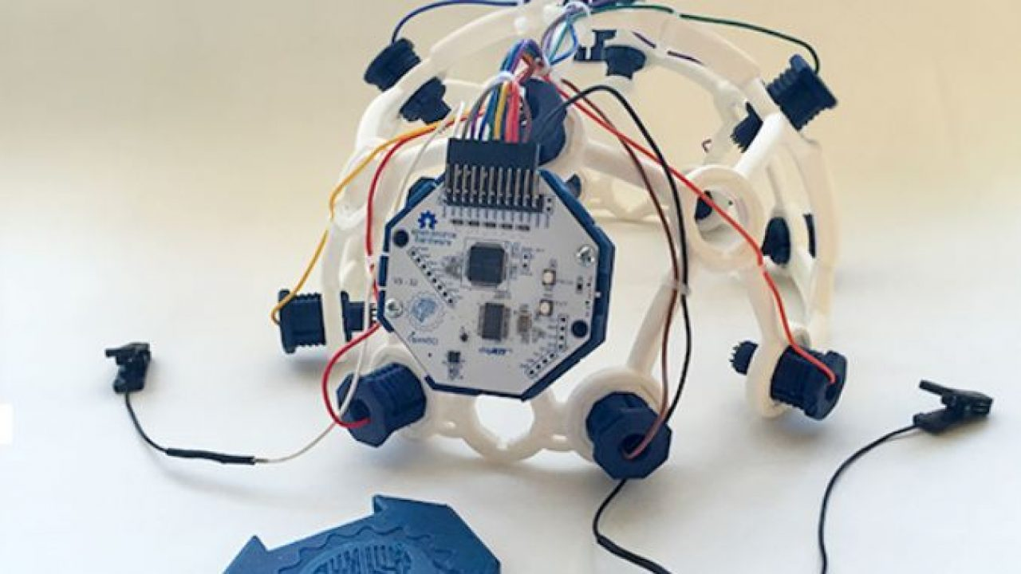
Fig 1: 3D printed headset, mounted with electrodes and the 8 channel Cyton board.

BCI is an acronym for Brain Computer Interface. In simple terms it is a collaboration between a brain and a computing device. These devices enable signals from the brain to direct some external activity, such as control of a cursor or a prosthetic limb. By reading signals from an array of neurons and using computer chips and programs to translate the signals into action, BCI can enable a person suffering from paralysis to write a book or control a motorized wheelchair or prosthetic limb through thought alone.
One of such tools is provided by OpenBCI. It specializes in creating low-cost, high-quality bio-sensing hardware and brain computer interfacing. The devices have been used by researchers, makers, and hobbyists in over 80 countries as BCIs to power machines and map brain activity.
The device used by us is the OpenBCI Ultracortex Mark IV which is an open-source, 3D printable headset (as shown above in Fig 1). It is capable of recording research-grade EEG along with 8 channel bio-sensing Cyton board (shown below Fig 2). The OpenBCI docs helped us a lot in getting the device ready and also helped us to configure the OpenBCI GUI for collecting the EEG signals. As every project team we faced a lot of challenges in our project, which emerged out from a number of fields/concepts.
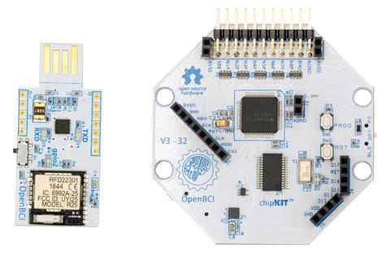Fig. 2: Programmable dongle (for Bluetooth connectivity) & Cyton Biosensing board (8 Channel).

EXPERIMENTAL METHODOLOGY
Data is the most important and fundamental element for any data science project. Quality and quantity are the two important properties of data. Hence a lot of efforts and research was done to design an experiment to collect data for analysis. Finally, we got some insights from one of the used data collection experiment for EEG analysis [1]. We modified the experiment according to our device’s computational and storage capabilities. The complete flow diagram of the experiment is shown in Fig 3. The experiment was carried out in a well-ventilated and quite room. The main factors that we were interested in were the BP readings of the subject, Heart rate of the subject along with the EEG data and the occupation of the Subject. We considered 3 categories of subjects based on the age and professions. The 3 categories of age groups are 10-25, 26-40 and 41-60. These 3 age groups mostly have different types and amounts of stress. For e.g., the people in the age group 10 - 25 are in their education and career building phase, usually going through academic stress, peer pressure etc. Similarly, the people in the age group 26-40 are in early professional phase going through stress due to workload, career building etc. and the people in the 41-60 age group are in their experienced professional phase usually dealing with chronic stress, family pressure etc. These 3 categories of people have different ways to cope up with stress. The 3 categories based on the professions are students, professors and other professionals.
To start with the experiment, we introduced the subject with our project objectives, information about the OpenBCI device and some facts about the brain. This helped us bring the attention of the subject completely towards our experiment. The initial BP and heart rate readings were noted down using the Digital BP Monitor. The OpenBCI headset Ultracortex Mark IV was placed on the subject’s head. Then the subject was given some tasks such as quizzes, puzzles and similar cognitive ability tests that they had to take in order to record the EEG. This activity included tasks such as find the difference, spot the mistake in the sentence, simple math problems, locating places on maps etc. This process was called as training period. This was done in order to amplify the stress levels of the subjects. At the same time, we were configuring the GUI screen so that we can confirm that the electrodes were in contact with the scalp and the GUI was rendering the data from the cyton board correctly. This activity took approximately 5 minutes. The subject was now told to rest by closing their eyes. The data collection was started at this point. This process was termed as relaxing period. The data was collected for a period of 2 minutes. This was the only data that we are using for analysis. After 2 minutes the subjects were told to open their eyes and the data recording was stopped. The final BP and heart rate readings were noted down. The headset was removed from the subject’s head. The subject was then given a feedback Google form. This form contained a set of questionnaires which were designed in consultation with psychiatrists and helps us to determine the stress level of the subject using perceived stress scale method. The stress labels are namely low stress, moderate stress and high stress. These labels later may be used as machine learning labels and help us build the model. This concluded the experiment. The average duration of the experiment was 15 minutes (per subject).

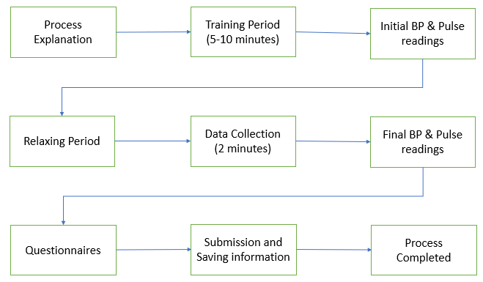
Fig. 3: Entire process of the Data Collection Experiment.

Challenges DURING the intial phases

Designing the tasks for training period
The training period was part of the process so as to amplify the stress level of the subject and also to bring the subjects attention completely towards the experiment hence enhancing the quality of data during the relaxing period. Symptoms for stress include forgetfulness, increased heart rate, swollen tongue and lost train of thought to name a few. Though our purpose is not to predict the stress state of the subject psychologically, the tasks should be designed in such a way that the subject should show some of the symptoms noted above. We found out some tasks from the popular National Geographic show ‘Brain Games’ and also some tasks such as locating and remembering things on map. In addition to this, use of timers, encouraging the subjects on correct answers and a bit of discouragement on wrong answers helped us achieve a perfect training session. Subjects were curious and at the same time nervous about their performance, resulting in expected behavioural change.

Data quality and acceptability
Several questions and discussions were carried out to finalize whether the data collected using Ultracortex Mark IV can be used for analysis of brain states and is the EEG data good enough to provide us expected model. After a lot of research and reference to OpenBCI documentation, it was clear that the EEG data collected has research grade quality and can be used to determine brain states. And also we confirmed that the EEG has successfully classified stress from the rest state with an accuracy of 85.55% and by using Yule Walker the classification rate was increased to an average of 90% [2]. Also skin conductance, heart rate variability and EEG signals combined to classify stress with an accuracy of 84.1%. And finally BP, skin conductance, heart rate variability and EEG signals have classified stress with accuracy of about 95% [2]. So it was clear that the model designed based on our projects parameters will have a good percentage of accuracy. One of the most important information that we had with us was the Perceived Stress Scale data (PSS), this is one of the traditional methods used by the psychiatrists to study stress levels in a subject. This information would help us attain a better accuracy to train our model and label the data that we collected after the training period. Also the addition of factors such as blood pressure and heart rate can help to attain a much better accuracy.

Data acquisition and storage
There were nearly 34,000 rows on average in the dataset for the data collection experiment of 2 minutes. The size of the dataset was approximately equal to 10MB. We had collected data of 25 subjects and the total size of the datasets was crossing 300MB. Storing this massive amount of data directly to online repositories was a problem as the repositories provide limited storage capacity. The configuration of the laptop or computer used for data collection should be good enough to store and render the OpenBCI GUI application. A computer with 8GB RAM, 2TB HDD and 2GB of graphic card is sufficient for processing the GUI application. Care needs to be taken to place the headset on the subject’s scalp as well, as the spiky electrodes should be touching the scalp correctly and it should not be turned with greater pressure while adjusting the electrodes

Raw Data
The OpenBCI GUI provides us with many tools for visualizing brain activity. The GUI can be configured with respect to filters such as band stop, band pass, notch etc. and also other parameters like smoothing, vertical scales and window for proper visualization. This means that the data being rendered in the GUI is filtered and clean. Our initial assumption was that the data that is rendered in the GUI is the one that is stored in the txt file of the recording. But the data in the txt file was completely raw and no filter was applied on the data. There were a lot of discussions in the OpenBCI forum regarding this data and answers in the forum made it clear that the data seen in the GUI during recording is filtered and we have the freedom to change and adjust the filters at the time, but the data in the txt file represents DC offset values which has a lot of noise associated with it as no filtering or denoising operations are being applied on it. This created a problem as the values in the file ranged from -24000µV to +50000 µV, whereas the normal EEG range lies between -100 µV to +100 µV. To bring down these high, out of range values within the normal range was a big challenge. Also as pointed out in one of the research paper, raw data obtained using OpenBCI board cannot be directly used for advanced EEG tasks such as analyzing brain states and the raw data output of the OpenBCI is within the time domain, however EEG and other bio-signals are usually analyzed in frequency domain [3]. Therefore, the data must be converted from time domain to frequency domain for effective analysis. Below is the screenshot of a dataset of a subject, shown in Fig 4, the data contains 24 columns and approximately 34,000 rows, containing the microvolt values of each micro-second.

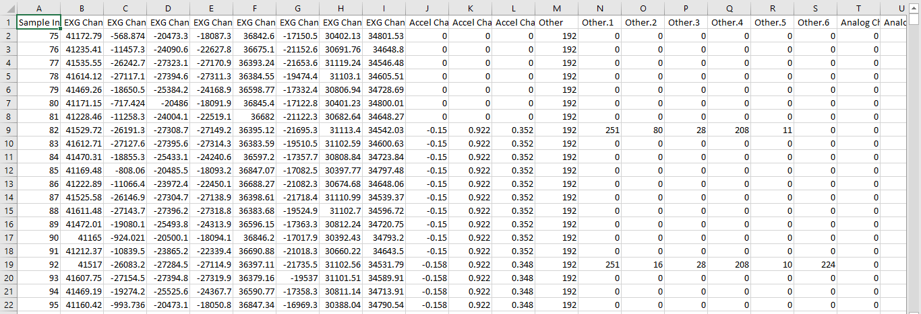

Fig 4: Screenshot of the raw csv data

Choosing the right pre-processing tool
Though there are several tools available today for processing digital signals, choosing the right tool for our data is critical. MATLAB gives us EEGLAB which supports 20 different binary file formats and also provides tools for time frequency analysis and ICA (Independent Component Analysis). Python as a versatile language has many packages such as scipy, dsptools/dsppy, pyopenbci, scikit-learn etc. and many authors who have contributed to the python community in the field of DSP have developed their own packages that cater the objectives of their books and its readers, these too are available globally and can be used. Similarly OpenBCI itself points out to a library called as brainflow, which is intended to obtain, parse and analyze EEG and other bio-signals. We chose to use this library as the GUI was rendering the graphs using the data that was cleaned in the backend by brainflow’s APIs. It not only contains APIs to clean the data but also to acquire data from the board and transfer it to the GUI and storage which will help us while developing a single data flow to analyze data from the board directly. And it also provides a good documentation to start with.

Data pre-processing
As mentioned earlier, the data stored in the txt file is unfiltered and raw. Hence the data needs to be cleaned for the next task of Exploratory Data Analysis (EDA). Several pre-processing workflows were available during the research phase but the techniques were either contradicting or not suitable for our objective. A workflow was designed as shown in Fig 5, considering the background of each of the techniques and also by understanding the terms, keywords and concepts mentioned in the techniques.

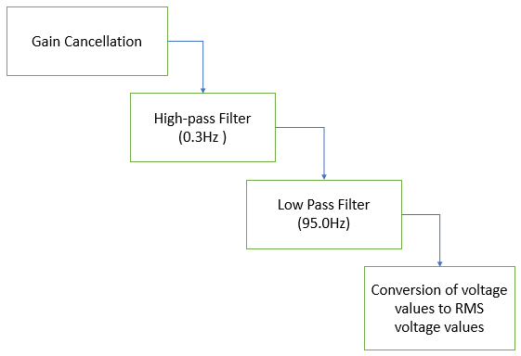
Fig 5: Workflow of the Data Preprocessing.

According to the workflow designed the first step was to cancel out the gain of the differential amplifier used in cyton board. The next few steps were to apply filters such as band pass and band stop filters. Finally converting the voltage values into RMS voltage values resulted in clean data i.e., the out-of-range EEG values are now completely in normal EEG range.
Some of the techniques also included down-sampling as a step. Down-sampling aggregates two or more consecutive rows of timestamps hence aggregating the number of samples per second. However, sampling rate of 250Hz is more adequate to characterize ERP components. Hence down-sampling was not omitted from our workflow.
The gain factor of the differential amplifier used in cyton board is 24 and as the first step this was removed by dividing the voltage values by 24. The next thing was to select the required filters and to set the correct parameters. Brainflow provided us with the filtering APIs and also the documentation contained all the necessary details to configure the filters. Keeping in mind that each filter adds up some adverse effects, the filters were selected and configured with justifiable parameters. The workflow suggested to use band-pass filter to attenuate unwanted signal frequencies in the data. But the band-pass filter was found less efficient when compared to application of low-pass filter and high-pass filter separately. Hence low-pass and high-pass filters with cutoff-frequencies as 95.0 Hz and 0.3 Hz respectively were applied. The low-pass filter attenuates signals which are above the cutoff-frequency and high-pass filter attenuates signals which are below the cutoff-frequency. The parameters for these filters were applied based on the brainflow docs and code snippets. To get efficient filtering values, 3rd order low-pass and high-pass filters were applied. The notch filter can also be used to cancel line noise at 50/60Hz. The notch filter is a band-stop filter with narrow band, and most of the time it introduces dramatic distortions of the original signal in frequency bands that are well outside the notch band. The statement was verified by using the filter and it was found to be true, hence notch filter was removed from the list. After converting the voltage into RMS voltage values the data is completely filtered and clean and can be used further for EDA process. The clean data when plotted had a sharp spike in the beginning which when verified was due to the initialization of channels. This spike is irrelevant for the experiment and can be ignored by deleting the initial few rows in the dataset.

Statistical and exploratory data analysis
Analyzing EEG signals is not as simple as analyzing other bio-signals such as EMG or ECG. EEG measures fluctuations in electrical activity of the brain over time [10]. These electrical activities are a result of synaptic activity between neurons. There are several hundreds to thousands of neurons under each electrode placed on the scalp. Therefore EEG analysis will be much trickier as we cannot simply do a spike per second or beats per minute analysis. Also the frequency range of EEG has a fuzzy upper and lower limit and ultra-fast and ultra-slow EEG components are not significant for analysis. Averaging the signal over many trials to see an evoked potential and building a spectrogram to see frequency changes over time are the two most common analysis techniques for EEG. Building a spectrogram decomposes a complex signal into its many frequency components often using a Fourier transform.
One of the useful feature that can be extracted from the EEG signals and used for EEG analysis is the ERP (Event Response Potential) that are electrical potentials associated with the presence of stimulus or response and can be used to measure rapid and implicit cognitive activity.
Another important feature that can be derived from EEG Signals is PSD which stands for Power Spectral Density that represents the power distribution of EEG signals in frequency domain. Power spectral analysis is a well-established method for analysis of EEG signals [7]. The PSD says how much of the given band (α, β, γ, δ, θ) is in the given signal.
The selection of electrodes for analysis is an important step. As different parts of the scalp corresponds to different lobes of the brain, we have to consider the electrodes from the region that are actively involved during negative emotions such as stress, depression, anxiety etc. [8][9] Usually the frontal lobe is responsible for problem solving, judgment and motor functions. It can be derived that the stress related signals will be predominantly available in the frontal lobe. Hence channels 0 and 1 of the 8 channel EEG device were considered for analysis. The next part was the selection of EEG bands from the alpha (α), beta (β), gamma (γ), delta (δ), and theta (θ) that captures stress related ERPs. The α bands with a frequency range of 8 – 12 Hz is usually observed in the parietal and occipital regions when the person is in conscious, quiet and rest state and its power decreases during active thinking. The β bands with frequency range of 13 – 30 Hz occurs in the frontal region during active thinking. The γ bands with a frequency range of 30 – 50 Hz is associated with perception, memory, consciousness, synaptic plasticity and motor control. The δ bands with a low frequency range below 3.5 Hz is usually present during periods of deep sleep, unconsciousness, anesthesia and lack of oxygen. It was noted that these bands are distributed over many different regions and hence can’t be linked to a particular region. Finally the θ bands with range of 4 – 7 Hz occurs in the parietal and temporal regions of the brain and are associated with moments of emotional pressure, interruptions of consciousness or deep physical relaxation. [6] So the bands of interest for our project were the alpha, beta, gamma and theta bands. The most important among them were the beta and the theta bands. The selection of the electrodes and EEG bands was clarified during a discussion with a neuro specialist.
The next step was the estimation of PSD for the channels. In general Welch’s method, FFT, and Burg’s method are most widely used to find PSD from the frequency bands [5]. The Welch’s method is a modified FFT approach which averages Fourier transform of a small window. Hence we used this approach to find the PSD of the particular channel. The parameters for the brainflow PSD API was set according to the documentation after confirming it with the objectives of the project. The PSD array obtained after the estimation was later used to find out the band powers of required EEG bands. The ratios of band powers such as the α/β, β/γ, β/θ were calculated for both the channels. Some other parameters like the SYS difference corresponding to difference between final and initial systolic BP readings and the DIA difference corresponding to final and initial diastolic BP readings were calculated. The heart rate or pulse difference between the final and initial heart rate readings were also calculated. The PSS score was calculated and the labels of the PSS score were recognized. These parameters calculated were converted into a dataset and the statistics of the datasets was visualized using different tools. It was found out that some of the data points were erroneous as they showed a lot of deflection from the other values and hence were termed as outliers and removed from the dataset. The correlation matrix showed that the PSS score is highly correlated with the DIA Difference and moderately correlated with the beta/theta channel 1 ratio. These two parameters when visualized using scatter plot perfectly showed two groups of data points. One corresponding to low stress and the other for moderate stress. The scatter plot for a few data points randomly selected can be observed in Fig 6.
After the entire EDA process the next step was to experiment the dataset with different machine learning models to predict the stress labels from the two features recognized.
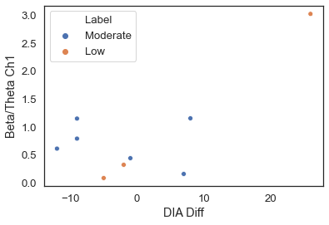
Fig 6. Scatter plot showing the relation of stress labels with the two features

Machine Learning
One of the main objective of the project was to experiment the dataset using different machine learning algorithms and to see which model performs the best. Machine Learning is a method where we train our model to analyze, understand and predict accurate results by training the model with information that’s relevant to our problem. The python library ‘scikit learn’ has lots of ML algorithms which makes our work easier. The dataset was split up into train and test sets with a ratio of 75:25. Starting with different classification algorithms like the KNN, SVM, logistic regression, decision tree, random forest we trained the models and tested their accuracy over 10 – 15 trials and derived observations from them.
The K-Nearest Neighbors is a supervised Machine Learning algorithm that is used for classification on the bases of the nearest data points to a reference equation. SVM or support vector machine is a supervised learning model that can solve linear and non-linear problems and works well for many practical problems. This algorithm creates a line or a hyper-plane which separates the data into classes. There is another version or variation of SVM called as the kernel SVM. Here we can provide a parameter for the kernel type used by the algorithm. The different kernel types available are linear, non-linear, polynomial, radial basis function (rbf) and sigmoid. The type of kernel selected will decide the type of curve that will be used to differentiate between the classes. Similarly logistic regression is also a supervised classification algorithm that uses an equation in order to classify the data into different classes. The Decision tree Model is a tree structured classifier, the nodes usually represent the feature of the data, and the branches represent the decisions that are to be taken. As an extension to the decision tree classifier, the Random Forest algorithm is an unsupervised Machine Learning algorithm that builds multiple decision trees and merges them all together to get more clear, accurate and stable decision. The results of the algorithms were noted and examined.

Results

Data Preprocessing Results
The results of the data cleaning experiment can be visualized using the figures shown below. The figures 6 and 7 shows the pattern of the micro-voltages for a single channel of a dataset over a range of 35000 rows. Fig. 6 shows the graph of the dataset before cleaning. The graph clearly indicates that most of the value’s range in between 40000 to 50000µV, which is very high compared to the normal EEG range of -100µV to +100µV. The data shows a high degree of noise factor added up to the EEG signals. This data was cleaned using the pre-processing technique and has effectively brought down the values into the typical EEG range.
The Fig. 7, shown below displays the result of the data pre-processing operation applied on the same channel. It can be observed that most of the values now range in between -100 µV to +100µV except for the sharp spikes in the beginning that corresponds to channel initialization as mentioned before.
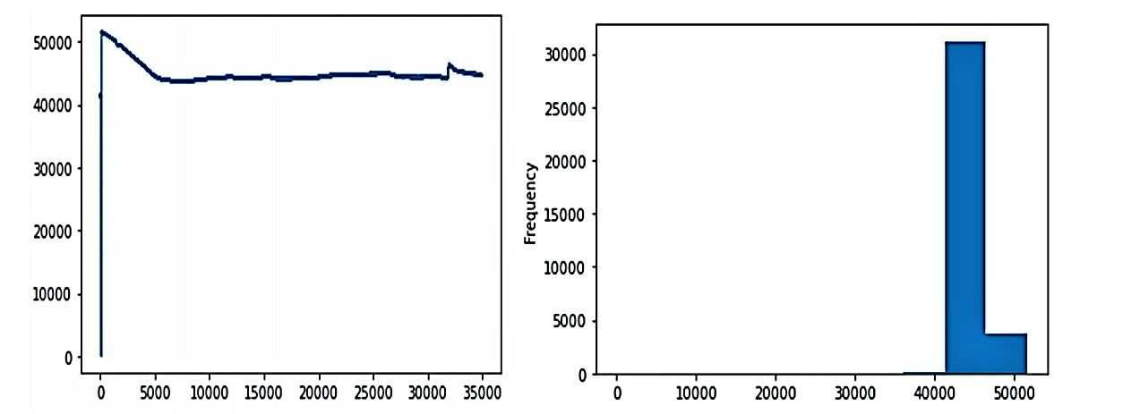
Fig. 7. Voltage values before pre-processing
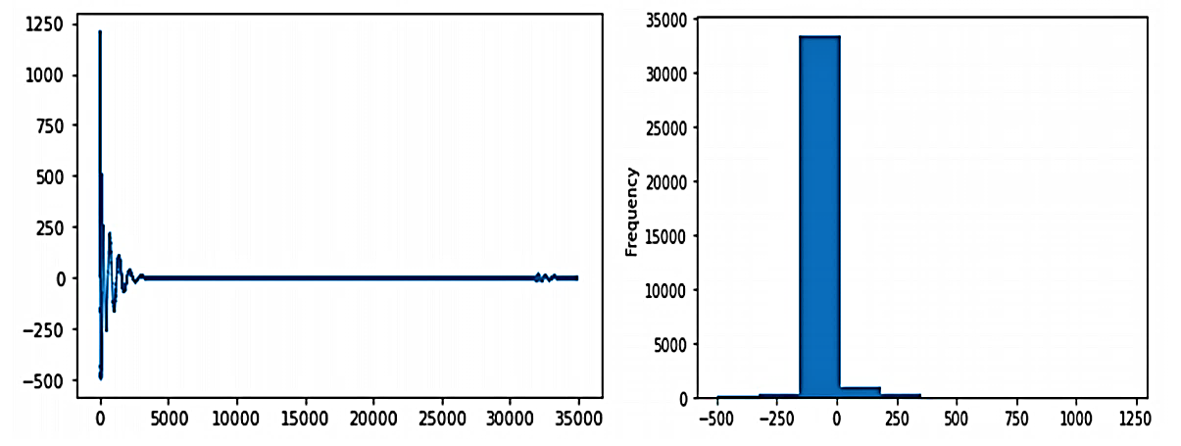
Fig. 8. Voltage values after pre-processing

Machine Learning results
The performance of different ML models can be visualized in Fig 9. As expected the KNN algorithm was not the best performer with an average accuracy of 33%. Other algorithms like the SVM, decision trees, logistic regression etc. performed with a constant accuracy of 67%. One thing to note here is that the performances of these models may vary based on the sample size and the random sampling of the data. But we can consider the SVM and Kernel SVM algorithms to be much better performers. As the accuracy was the same for all the trials and was unaffected by the sampling of the dataset. The results of the machine learning part gives us an indication that if the data is collected on a large population then the accuracy of the algorithms will be much better and the entire project will be a great success. The experiment should be performed in such a way that it can accommodate data collection for more number of subjects. Also during the EDA process it was noted that few of the data rows were not perfect and were considered as outliers and hence removed from the dataset. This further reduced the size of the dataset.

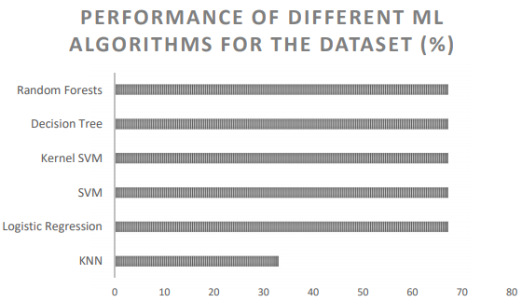

Fig. 9. Results of various Machine Learning Models

conclusion
We do know that technology has helped us complete a lot of major tasks that require utmost concentration which many a time humans miss of fail to cope. One such was the project where instead of relying on the psychological information provided by the subject, to predict the stress levels, which most of the time is biased. We can directly use this solution to determine the stress levels of the human more accurately. The project is not only limited to estimating the stress levels but can also be used to predict other negative emotions such as anxiety, depression, tension etc. with slight modifications to the data collection experiment. For analyzing other negative emotions or mental states, the data collection experiment should be designed relative to the symptoms of the mental state. This paper and the research work carried out by us can be used for future work in the domain. The data cleaning process was prepared using the brainflow APIs and documentation and is flexible to be translated into various languages. Thus providing an easy to use solution for the challenging and tricky part of EEG data preprocessing. In future researchers can also try to explore new features of EEG and spectral analysis techniques. The project and this paper will not only help neuro-specialists and psychiatrists to perform quick analysis of subjects but also gives a way for parents to monitor their child’s mental status periodically. Also use of BCI devices to predict stress will be so much helpful and easy for anyone to keep track at the comfort of their homes. Therefore we can conclude that this project will be really helpful in the long run and especially for bringing the balance which is deteriorated because of the covid-19.

References

- FM Al-Shargie, Tong Boon Tang, Nasreen Badrudddin, Masashi Kiguchi, “Mental stress quantification using EEG signals”. International Conference for innovation in Biomedical Engineering and Life Sciences, 15-19, 2015.
- Ernst Niedermeyer, “Normal EEG of the waking adult”. Electroencephalography: basic principles, clinical applications and related fields 20 (4), 149-173, 1999.
- “Feature Extraction and Signal Processing of Open-Source Brain-Computer interface”, 2nd annual undergraduate research expo, university of Texas – Dallas, February 2016..
- “EEG signal analysis and detection of stress using classification techniques” Ruchi Sharma & Khyati Chopra, ISSN: 0252-2667

[5] Raquib-ul Alam, Haifeng Zhao, Andrew Goodwin, Omid Kavehei, Alistair McEwan, “Differences in Power Spectral Densities and Phase Quantitites due to processing of EEG Signals”, Article in Sensors 20 (21), 6285, November 2020.

[6] “EEG-Based Tool for Prediction of University Students Cognitive Performance in the classroom”, Article in Brain Sciences 11 (6), 698, May 2021.
[7] Dennis McFarland, Lynn Mccane, Stephen V David, Jonathan Wolpaw, “Spatial filter selection for EEG-based communication. Electroencephalogr Clin NeuroPhysiol, Article in Electroencephalography And Clinical Neurophysiology, October 1997.
[8] Seyyed Abed Hossieni, Mohammad Ali Khalizadeh, “ Emotional Stress Recognition system using EEG and Psychophysiological signals, 2010 International Conference on Biomedical engineering and computer science, 1-6, 2010.
[9] Niha Kb, Aisha banu, “Brain Signal Processing: Technologies, Analysis and Application”, 2016 International Conference on Computational intelligence and Computing Research (ICCIC) , December 2019.
[10] Glenna L. Read, Isaih J. Innis, “Electroencephalogram (EEG)”, The International encyclopedia of communication research methods, 1-18, August 2017.
[11] EEG Basics, CiMEC Wiki Page, 2020, <wiki.cimec.unitn.it/tiki-index.php?page=Data+pre-processing>
[12] BrainFlow: Replicating the pre-processing steps from the GUI, OpenBCI Forum, MrKlean518, February 2020, <https://openbci.com/forum/index.php?p=/discussion/2478/brainflow-replicating-the-pre-processing-steps-from-the-gui>

